Test Report
测试报告

No. C191111049001
编号: C191111049001

Date: Nov 16, 2019
日期: 2019年11月16日

Page 1 of 5
第1页,共5页

Applicant: GUANGZHOU ZHUANCAI CHEMICAL TRADE CO. LTD
申请商: 广州市专彩化工贸易有限公司
Applicant Address: NO.15, LAIYIN GARDEN FIRST STREET, ZENGCHENG DISTRICT, GUANGZHOU CITY
申请商地址: 广州市增城区莱茵花园一街15号

The following samples were submitted and identified on behalf of the clients as
以下测试之样品是由申请者所提供及确认

Sample Name:
样品名称:
CPST Internal Reference No: CPST 参考编号:
Date of Sample Received:
收 样 日 期 : Testing Period: 测试周期:
Test Method: 测试方法: Test Result: 测试结果:
G3 Light oil G3光油C191111049 C191111049 Nov 11, 2019
2019年11月11日
Nov 11, 2019 to Nov 16, 2019
2019年11月11日至2019年11月16日Please refer to next page(s)
请参见下一页
Please refer to next page(s)
请参见下一页

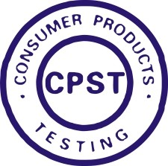
Signed for and on behalf of
Eurones Consumer Products Testing Service Co., Ltd

TESTED BY : REVIEWED BY: APPROVED BY:

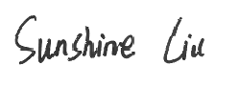

Wan Da Wei, David Project Leader
Liu Xiao Fang, Sunshine Report Reviewer

Pan Jian Ding, Will Technical Supervisor

This Test Report is issued by the Company subject to its General Conditions of Service printed overleaf or available on request and accessible at www.cpstlab.com. Attention is drawn to the limitations of liability, indemnification and jurisdictional issues defined therein. Unless otherwise stated the results shown in the test report refer only to the sample(s) tested. This test report cannot be reproduced, except in full, without prior written permission of the Company. Any unauthorized alteration, forgery or falsification of the content or appearance of this report is unlawful and offenders may be prosecuted to the fullest extent of the law.



400 111 6218

Eurones (Dongguan) Consumer Products Testing Service Co., Ltd. .t (86-769) 38937858 f (86-769) 38937859 Http:// www.cpstlab.com Room 1092, No.12, East Houjie Avenue, Houjie, Dongguan, Guangdong, China. Postcode: 523945 service@cpstlab.com

Test Report
测试报告

No. C191111049001
编号: C191111049001

Date: Nov 16, 2019
日期: 2019年11月16日

Page 2 of 5
第2页,共5页

******************************************************************************************************************************* CONCLUSION:
结论 :

TESTED SAMPLES
测试样品

G3 Light oil G3 光油
TEST ITEM
测试项目
1.Nonylphenol ethoxylates (NPEO)content- the entry 46 in Annex XVII of the REACH Regulation (EC) NO.1907/2006
1.壬基酚聚氧乙烯醚(NPEO)的含量
-REACH法规(EC) NO.1907/2006附件XVII中的第46条
RESULT
结果

PASS

合格

*******************************************************************************************************************************

This Test Report is issued by the Company subject to its General Conditions of Service printed overleaf or available on request and accessible at www.cpstlab.com. Attention is drawn to the limitations of liability, indemnification and jurisdictional issues defined therein. Unless otherwise stated the results shown in the test report refer only to the sample(s) tested. This test report cannot be reproduced, except in full, without prior written permission of the Company. Any unauthorized alteration, forgery or falsification of the content or appearance of this report is unlawful and offenders may be prosecuted to the fullest extent of the law.

400 111 6218

Eurones (Dongguan) Consumer Products Testing Service Co., Ltd. .t (86-769) 38937858 f (86-769) 38937859 Http:// www.cpstlab.com Room 1092, No.12, East Houjie Avenue, Houjie, Dongguan, Guangdong, China. Postcode: 523945 service@cpstlab.com

Test Report
测试报告

No. C191111049001
编号: C191111049001

Date: Nov 16, 2019
日期: 2019年11月16日

Page 3 of 5
第3页,共5页

Photo of the Submitted Sample
送检样品照片
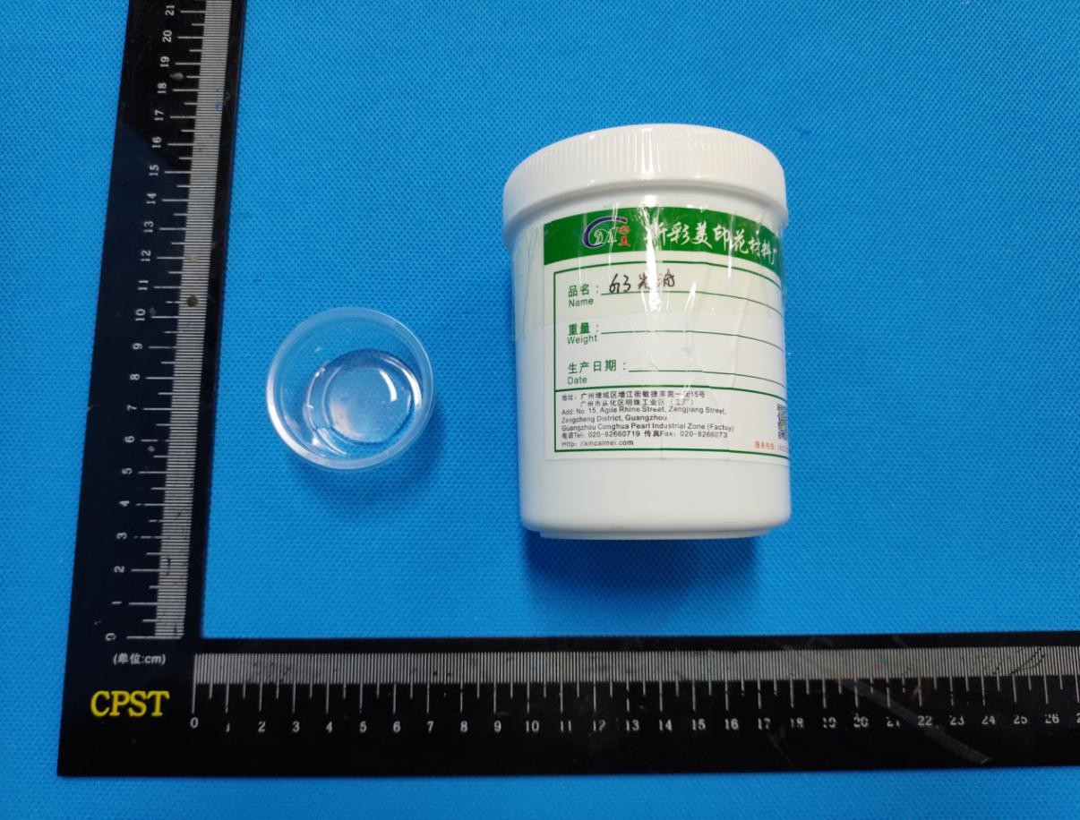

This Test Report is issued by the Company subject to its General Conditions of Service printed overleaf or available on request and accessible at www.cpstlab.com. Attention is drawn to the limitations of liability, indemnification and jurisdictional issues defined therein. Unless otherwise stated the results shown in the test report refer only to the sample(s) tested. This test report cannot be reproduced, except in full, without prior written permission of the Company. Any unauthorized alteration, forgery or falsification of the content or appearance of this report is unlawful and offenders may be prosecuted to the fullest extent of the law.

400 111 6218

Eurones (Dongguan) Consumer Products Testing Service Co., Ltd. .t (86-769) 38937858 f (86-769) 38937859 Http:// www.cpstlab.com Room 1092, No.12, East Houjie Avenue, Houjie, Dongguan, Guangdong, China. Postcode: 523945 service@cpstlab.com

Test Report
测试报告

No. C191111049001
编号: C191111049001

Date: Nov 16, 2019
日期: 2019年11月16日

Page 4 of 5
第4页,共5页

Test Result(s):
测试结果：
Description of Specimen:
样品描述:

Transparent liquid
透明液体

1. Nonylphenol ethoxylates (NPEO) content- the entry 46 in Annex XVII of the REACH Regulation (EC) NO.1907/2006
1. 壬基酚聚氧乙烯醚(NPEO)的含量 - REACH 法规(EC) NO.1907/2006 附件 XVII 中的第 46 条
Test Method: With reference to US EPA 3540C:1996, analysis was performed by Liquid Chromatograph Mass Spectrometer (LC-MS).
测试方法:参考 US EPA 3540C:1996, 使用液相色谱质谱联用仪(LC-MS)进行分析。
Test Item  测试项目 | CAS No. | Unit  单位 | Result  结果 | MDL | Limit  限值
Nonylphenol ethoxylates (NPEO)  壬基酚聚氧乙烯醚(NPEO) | 9016-45-9 | mg/kg | N.D. | 30 | 1000

Note:  1. mg/kg = milligram per kilogram = ppm | 注释: | 1. mg/kg = 毫克每千克 = ppm
2. N.D. = Not Detected (< MDL) |  | 2. N.D. = 未检出 (< MDL)
3. MDL = Method Detection Limit |  | 3. MDL = 方法检测限

This Test Report is issued by the Company subject to its General Conditions of Service printed overleaf or available on request and accessible at www.cpstlab.com. Attention is drawn to the limitations of liability, indemnification and jurisdictional issues defined therein. Unless otherwise stated the results shown in the test report refer only to the sample(s) tested. This test report cannot be reproduced, except in full, without prior written permission of the Company. Any unauthorized alteration, forgery or falsification of the content or appearance of this report is unlawful and offenders may be prosecuted to the fullest extent of the law.

400 111 6218

Eurones (Dongguan) Consumer Products Testing Service Co., Ltd. .t (86-769) 38937858 f (86-769) 38937859 Http:// www.cpstlab.com Room 1092, No.12, East Houjie Avenue, Houjie, Dongguan, Guangdong, China. Postcode: 523945 service@cpstlab.com

Test Report
测试报告

No. C191111049001
编号: C191111049001

Date: Nov 16, 2019
日期: 2019年11月16日

Page 5 of 5
第5页,共5页

Nonylphenol ethoxylates (NPEO) Testing Flow Chart
壬基酚聚氧乙烯醚(NPEO) 测试流程图

Cutting/ Preparation/机械制样

Weigh Sample/样品称量

Sample solvent extraction/
采用有机溶剂萃取样品

Concentration/ Dilution of Extracted solution 浓缩或稀释萃取溶液

Filtration/过滤

LC-MS analyze LC-MS 分析

DATA/数据

*** End of Report ***
*** 报告结束 ***

This Test Report is issued by the Company subject to its General Conditions of Service printed overleaf or available on request and accessible at www.cpstlab.com. Attention is drawn to the limitations of liability, indemnification and jurisdictional issues defined therein. Unless otherwise stated the results shown in the test report refer only to the sample(s) tested. This test report cannot be reproduced, except in full, without prior written permission of the Company. Any unauthorized alteration, forgery or falsification of the content or appearance of this report is unlawful and offenders may be prosecuted to the fullest extent of the law.

400 111 6218

Eurones (Dongguan) Consumer Products Testing Service Co., Ltd. .t (86-769) 38937858 f (86-769) 38937859 Http:// www.cpstlab.com Room 1092, No.12, East Houjie Avenue, Houjie, Dongguan, Guangdong, China. Postcode: 523945 service@cpstlab.com

