Test Report
测试报告

No. C191111049002
编号: C191111049002

Date: Nov 16, 2019
日期: 2019年11月16日

Page 1 of 8
第1页,共8页

Applicant: GUANGZHOU ZHUANCAI CHEMICAL TRADE CO. LTD
申请商: 广州市专彩化工贸易有限公司
Applicant Address: NO.15, LAIYIN GARDEN FIRST STREET, ZENGCHENG DISTRICT, GUANGZHOU CITY
申请商地址: 广州市增城区莱茵花园一街15号

The following samples were submitted and identified on behalf of the clients as
以下测试之样品是由申请者所提供及确认

Sample Name:
样品名称:
CPST Internal Reference No: CPST 参考编号:
Date of Sample Received:
收 样 日 期 : Testing Period: 测试周期:
Test Method: 测试方法: Test Result: 测试结果:
101A slowly sublimates white 101A缓升华白色C191111049
C191111049 Nov 11, 2019 2019年11月11日
Nov 11, 2019 to Nov 16, 2019
2019年11月11日至2019年11月16日Please refer to next page(s)
请参见下一页
Please refer to next page(s)
请参见下一页

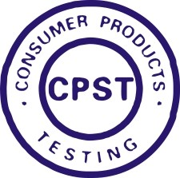
Signed for and on behalf of
Eurones Consumer Products Testing Service Co., Ltd

TESTED BY : REVIEWED BY: APPROVED BY:




Wan Da Wei, David Project Leader
Liu Xiao Fang, Sunshine Report Reviewer
Pan Jian Ding, Will Technical Supervisor

This Test Report is issued by the Company subject to its General Conditions of Service printed overleaf or available on request and accessible at www.cpstlab.com. Attention is drawn to the limitations of liability, indemnification and jurisdictional issues defined therein. Unless otherwise stated the results shown in the test report refer only to the sample(s) tested. This test report cannot be reproduced, except in full, without prior written permission of the Company. Any unauthorized alteration, forgery or falsification of the content or appearance of this report is unlawful and offenders may be prosecuted to the fullest extent of the law.




400 111 6218

Eurones (Dongguan) Consumer Products Testing Service Co., Ltd. .t (86-769) 38937858 f (86-769) 38937859 Http:// www.cpstlab.com Room 1092, No.12, East Houjie Avenue, Houjie, Dongguan, Guangdong, China. Postcode: 523945 service@cpstlab.com

Test Report
测试报告

No. C191111049002
编号: C191111049002

Date: Nov 16, 2019
日期: 2019年11月16日

Page 2 of 8
第2页,共8页

******************************************************************************************************************************* CONCLUSION:
结论 :

TESTED SAMPLES
测试样品

101A slowly sublimates white 101A 缓升华白色
TEST ITEM
测试项目
1. Migration of certain elements—The European Standard for safety of toys EN 71-3:2019
1. 某些元素的可溶性迁移含量—欧洲玩具安全标准EN
71-3:2019
RESULT
结果

PASS

合格

*******************************************************************************************************************************

This Test Report is issued by the Company subject to its General Conditions of Service printed overleaf or available on request and accessible at www.cpstlab.com. Attention is drawn to the limitations of liability, indemnification and jurisdictional issues defined therein. Unless otherwise stated the results shown in the test report refer only to the sample(s) tested. This test report cannot be reproduced, except in full, without prior written permission of the Company. Any unauthorized alteration, forgery or falsification of the content or appearance of this report is unlawful and offenders may be prosecuted to the fullest extent of the law.

400 111 6218

Eurones (Dongguan) Consumer Products Testing Service Co., Ltd. .t (86-769) 38937858 f (86-769) 38937859 Http:// www.cpstlab.com Room 1092, No.12, East Houjie Avenue, Houjie, Dongguan, Guangdong, China. Postcode: 523945 service@cpstlab.com

Test Report
测试报告

No. C191111049002
编号: C191111049002

Date: Nov 16, 2019
日期: 2019年11月16日

Page 3 of 8
第3页,共8页

Photo of the Submitted Sample
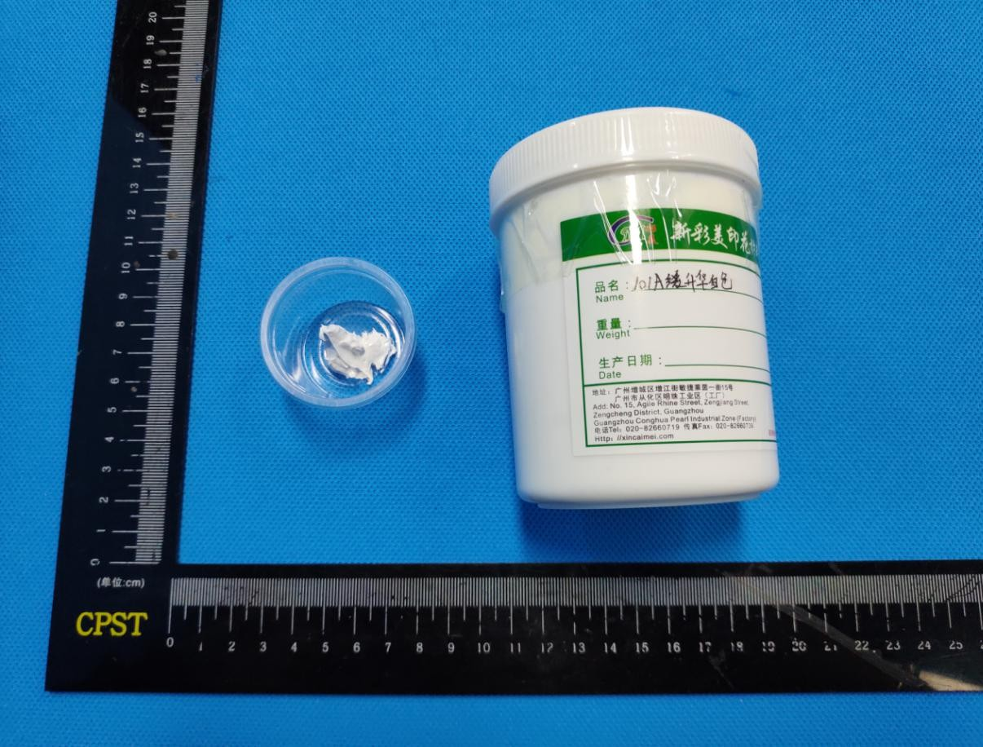
送检样品照片

This Test Report is issued by the Company subject to its General Conditions of Service printed overleaf or available on request and accessible at www.cpstlab.com. Attention is drawn to the limitations of liability, indemnification and jurisdictional issues defined therein. Unless otherwise stated the results shown in the test report refer only to the sample(s) tested. This test report cannot be reproduced, except in full, without prior written permission of the Company. Any unauthorized alteration, forgery or falsification of the content or appearance of this report is unlawful and offenders may be prosecuted to the fullest extent of the law.

400 111 6218

Eurones (Dongguan) Consumer Products Testing Service Co., Ltd. .t (86-769) 38937858 f (86-769) 38937859 Http:// www.cpstlab.com Room 1092, No.12, East Houjie Avenue, Houjie, Dongguan, Guangdong, China. Postcode: 523945 service@cpstlab.com

Test Report
测试报告

No. C191111049002
编号: C191111049002

Date: Nov 16, 2019
日期: 2019年11月16日

Page 4 of 8
第4页,共8页

Test Result(s):
测试结果：
Description of Specimen:
样品描述:

White paste
白色膏状物

1. Migration of certain elements —The European Standard for safety of toys EN 71-3:2019 1. 某些元素的可溶性迁移含量—欧洲玩具安全标准 EN 71-3:2019
Test Method: With reference to EN 71-3:2019, analysis was performed by Instruments.
测试方法: 参考EN 71-3:2019，使用仪器进行分析。
Test Items  测试项目 | Unit  单位 | Result  结果 | MDL
Test Items  测试项目 | Unit  单位 | Category III  材料种类 III | MDL
Soluble Aluminum(Al)  可溶出的铝(Al) | mg/kg | 541 | 5
Soluble Antimony(Sb)  可溶出的锑(Sb) | mg/kg | N.D. | 0.02
Soluble Arsenic(As)  可溶出的砷(As) | mg/kg | N.D. | 0.02
Soluble Barium(Ba)  可溶出的钡(Ba) | mg/kg | N.D. | 5
Soluble Boron(B)  可溶出的硼(B) | mg/kg | N.D. | 5
Soluble Cadmium(Cd)  可溶出的镉(Cd) | mg/kg | N.D. | 0.05
Soluble trivalent chromium(Cr3+)  可溶出的三价铬(Cr3+) | mg/kg | N.D. | 0.05
Soluble hexavalent chrome(Cr6+)  可溶出的六价铬(Cr6+) | mg/kg | N.D. | 0.02
Soluble Cobalt (Co)  可溶出的钴(Co) | mg/kg | N.D. | 0.02
Soluble Copper (Cu)  可溶出的铜(Cu) | mg/kg | N.D. | 5
Soluble Lead (Pb)  可溶出的铅(Pb) | mg/kg | N.D. | 0.05

This Test Report is issued by the Company subject to its General Conditions of Service printed overleaf or available on request and accessible at www.cpstlab.com. Attention is drawn to the limitations of liability, indemnification and jurisdictional issues defined therein. Unless otherwise stated the results shown in the test report refer only to the sample(s) tested. This test report cannot be reproduced, except in full, without prior written permission of the Company. Any unauthorized alteration, forgery or falsification of the content or appearance of this report is unlawful and offenders may be prosecuted to the fullest extent of the law.

400 111 6218

Eurones (Dongguan) Consumer Products Testing Service Co., Ltd. .t (86-769) 38937858 f (86-769) 38937859 Http:// www.cpstlab.com Room 1092, No.12, East Houjie Avenue, Houjie, Dongguan, Guangdong, China. Postcode: 523945 service@cpstlab.com

Test Report
测试报告

No. C191111049002
编号: C191111049002

Date: Nov 16, 2019
日期: 2019年11月16日

Page 5 of 8
第5页,共8页

Test Items  测试项目 | Unit  单位 | Result  结果 | MDL
Test Items  测试项目 | Unit  单位 | Category III  材料种类 III | MDL
Soluble Manganese (Mn)  可溶出的锰(Mn) | mg/kg | N.D. | 5
Soluble Mercury (Hg)  可溶出的汞(Hg) | mg/kg | N.D. | 0.02
Soluble Nickel (Ni)  可溶出的镍(Ni) | mg/kg | N.D. | 0.05
Soluble Selenium (Se)  可溶出的硒(Se) | mg/kg | N.D. | 0.2
Soluble strontium (Sr)  可溶出的锶(Sr) | mg/kg | N.D. | 5
Soluble Tin (Sn)  可溶出的锡(Sn) | mg/kg | N.D. | 5
Soluble Organotin  可溶出的有机锡 | mg/kg | N.D. | 0.1
Soluble Zinc (Zn)  可溶出的锌(Zn) | mg/kg | N.D. | 5
Conclusion  结论 | PASS  合格

Note:  1. mg/kg = milligram per kilogram = ppm | 注释: | 1. mg/kg = 毫克每千克 = ppm
2. N.D. = Not Detected (< MDL) |  | 2. N.D. = 未检出 (< MDL)
3. MDL = Method Detection Limit |  | 3. MDL = 方法检测限

This Test Report is issued by the Company subject to its General Conditions of Service printed overleaf or available on request and accessible at www.cpstlab.com. Attention is drawn to the limitations of liability, indemnification and jurisdictional issues defined therein. Unless otherwise stated the results shown in the test report refer only to the sample(s) tested. This test report cannot be reproduced, except in full, without prior written permission of the Company. Any unauthorized alteration, forgery or falsification of the content or appearance of this report is unlawful and offenders may be prosecuted to the fullest extent of the law.

400 111 6218

Eurones (Dongguan) Consumer Products Testing Service Co., Ltd. .t (86-769) 38937858 f (86-769) 38937859 Http:// www.cpstlab.com Room 1092, No.12, East Houjie Avenue, Houjie, Dongguan, Guangdong, China. Postcode: 523945 service@cpstlab.com

